SYSTEM ARCHITECTURE

 LOGIN 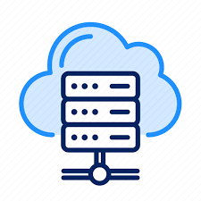
USER INTERFACE
FILE UPLOAD
USER Verify user CLOUD SERVER

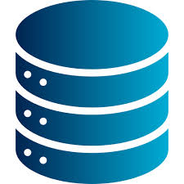
DATABASE
SAVE LOG
VIEW LOG

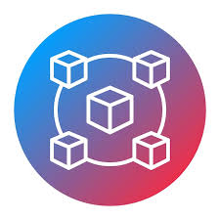
BLOCKCHAIN SERVER

